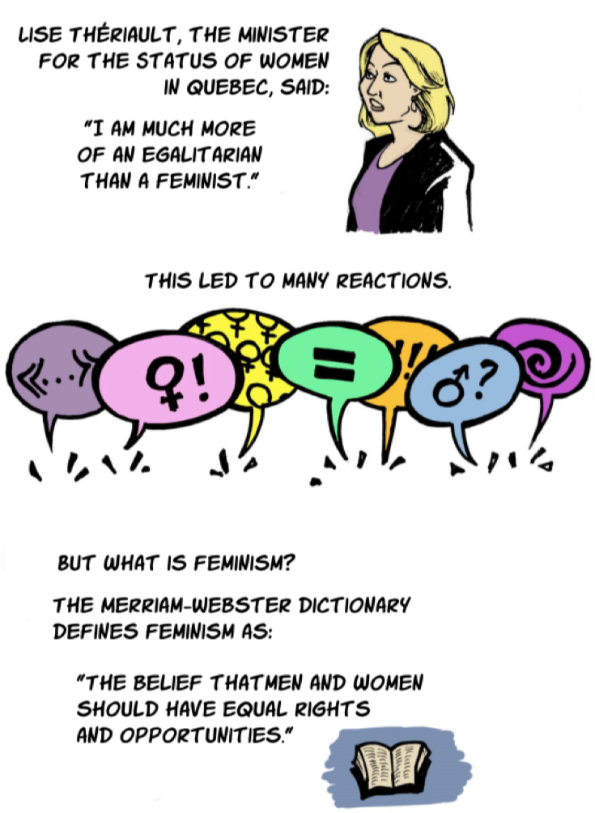
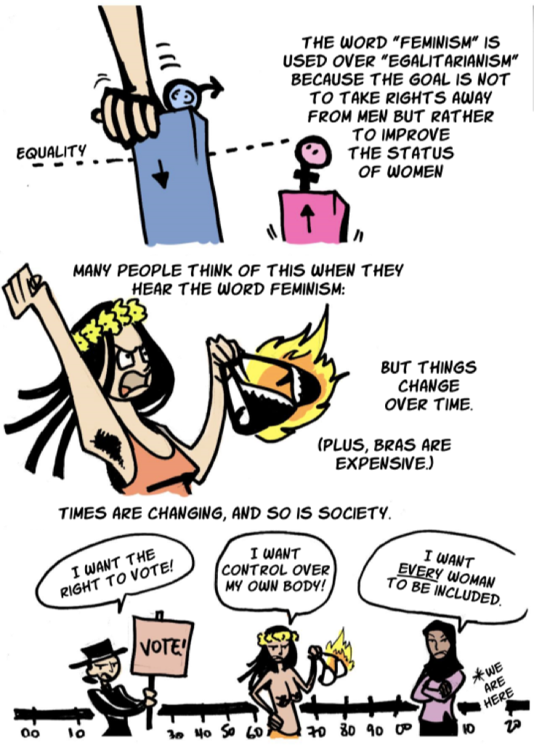

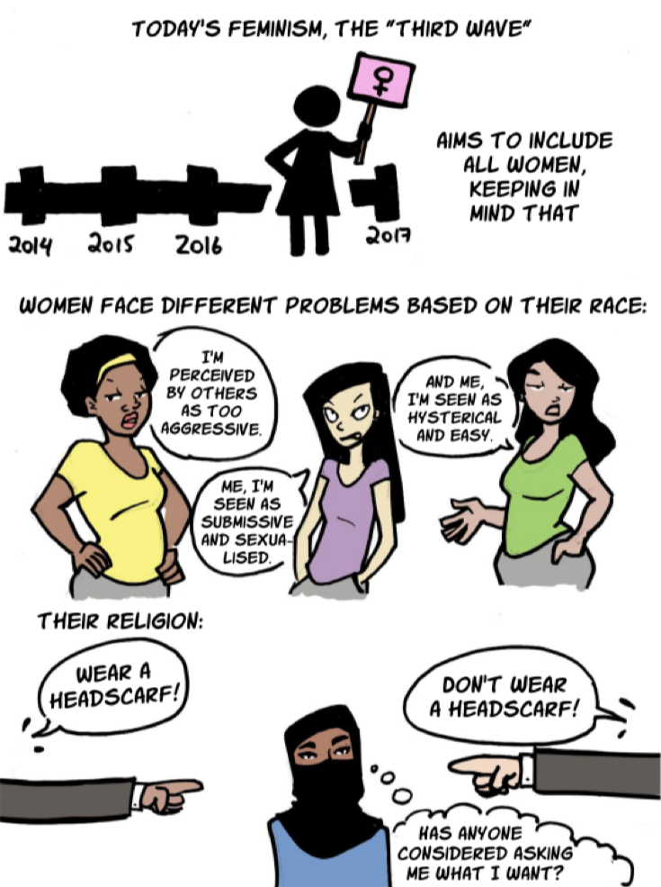
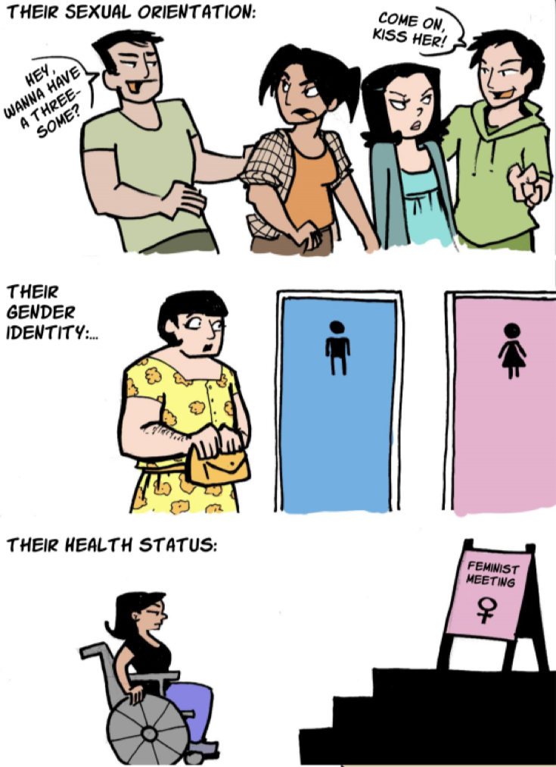
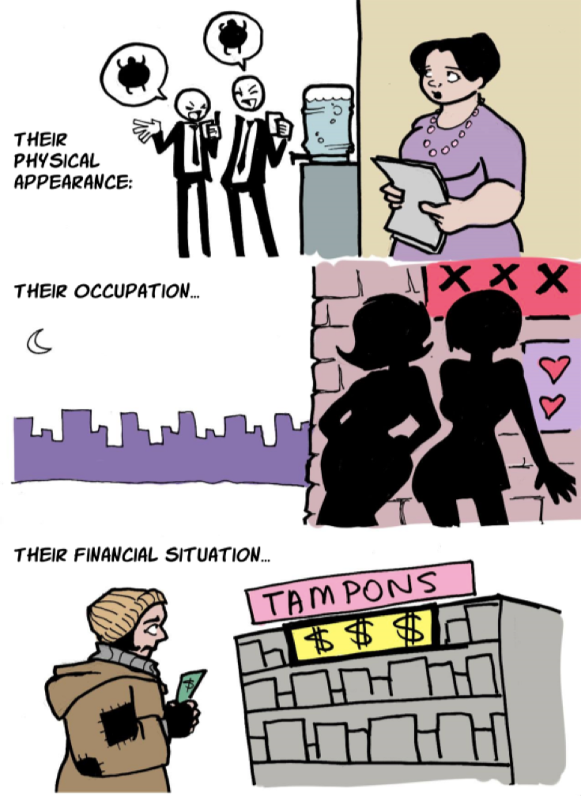
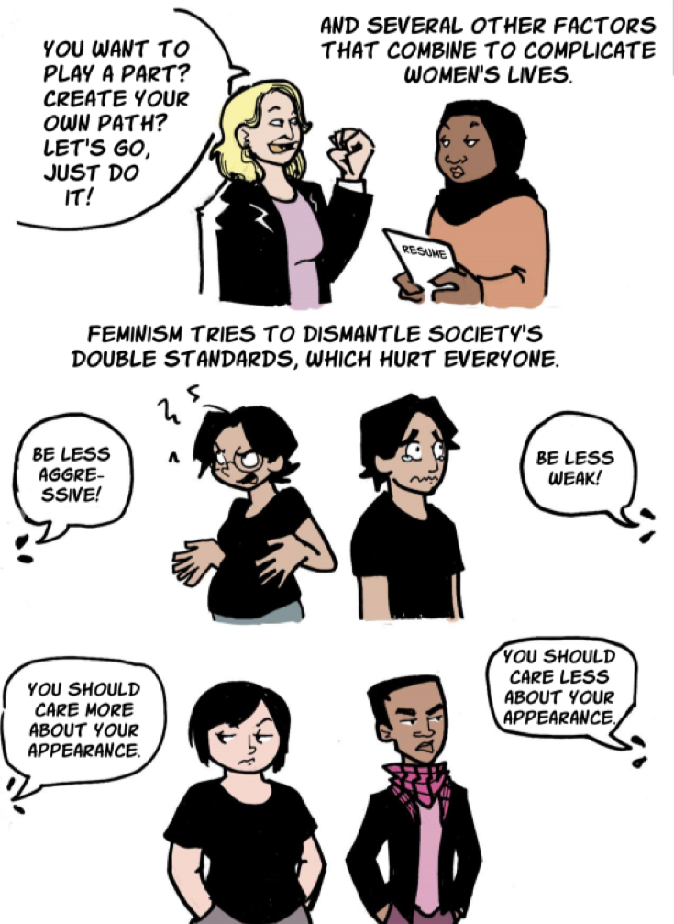

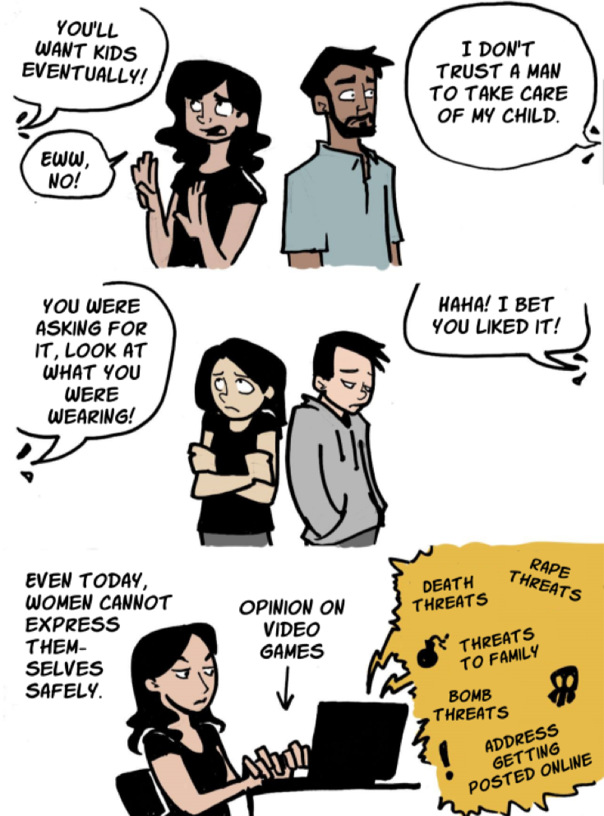
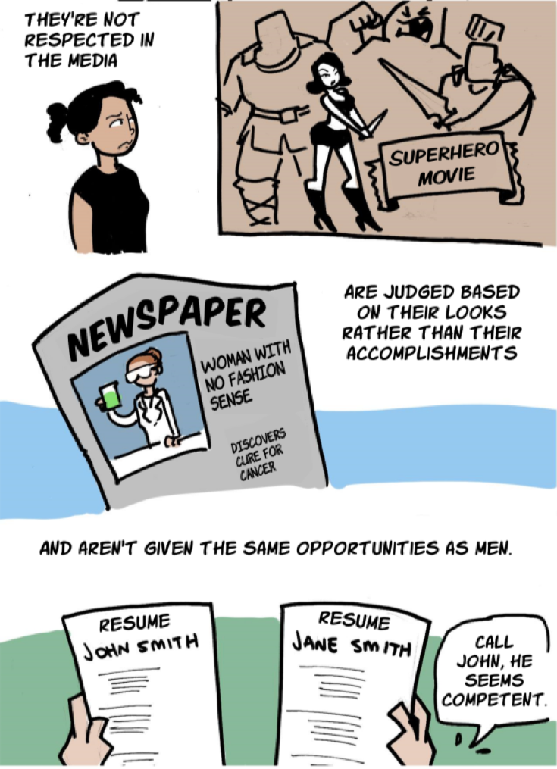
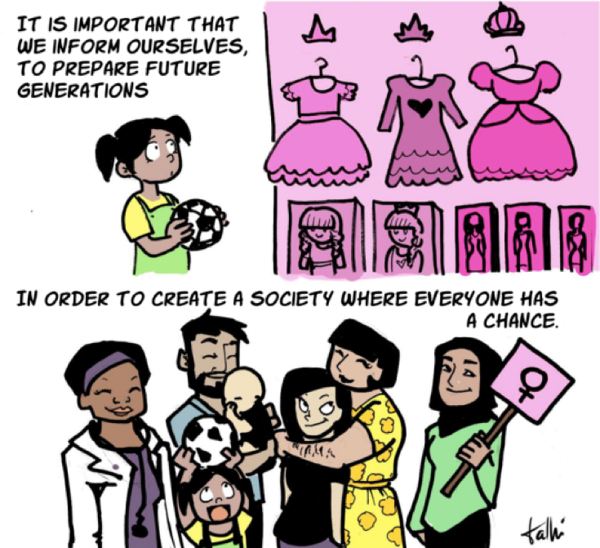

Illustrator: Talhí Briones
http://www.upworthy.com/what-is-feminism-really-this-comic-sums-it-up-well
Published on Upworthy. August 22, 2016.

COMPLETE VERSION
October 12 2016 8:30AM
Chimamanda Ngozi Adichie Facebook Post

“DEAR IJEAWELE, OR A FEMINIST MANIFESTO IN FIFTEEN SUGGESTIONS”
By Chimamanda Adichie
Dear Ijeawele,
What joy. And what lovely names: Chizalum Adaora. She is so beautiful. Only a day old and she already looks curious about the world. Your note made me cry. You know how I get foolishly emotional sometimes. Please know that I take your charge – how to raise her feminist – very seriously. And I understand what you mean by not always knowing what the feminist response to situations should be. For me, feminism is always contextual. I don’t have a set-in-stone rule; the closest I have to a formula are my two ‘Feminist Tools’ and I want to share them with you as a starting point.
The first is your premise, the solid unbending belief that you start off with. What is your premise? Your feminist premise should be: I matter. I matter equally. Not ‘if only.’ Not ‘as long as.’ I matter equally. Full stop.
The second tool is a question: can you reverse X and get the same results?
For example: many people believe that a woman’s feminist response to a husband’s infidelity should be to leave. But I think staying can also be a feminist choice, depending on the context. If Chudi sleeps with another woman and you forgive him, would the same be true if you slept with another man? If the answer is yes then your choosing to forgive him can be a feminist choice because it is not shaped by a gender inequality. Sadly, the reality in most marriages is that the answer to that question would often be no, and the reason would be gender-based – that absurd idea of ‘men will be men.’
I have some suggestions for how to raise Chizalum. But remember that you might do all the things I suggest, and she will still turn out to be different from what you hoped, because sometimes life just does its thing. What matters is that you try. And always trust your instincts, above all else, because you will be guided by your love for your child.
Here are my suggestions:
1. First Suggestion: Be a full person. Motherhood is a glorious gift, but do not define yourself solely by motherhood. Be a full person. Your child will benefit from that. The pioneering American journalist Marlene Sanders once said to a younger journalist, “Never apologize for working. You love what you do, and loving what you do is a great gift to give your child.”
You don’t even have to love your job; you can merely love what your job does for you – the confidence and self-fulfillment that come with doing and earning. Reject the idea of motherhood and work as mutually exclusive. Our mothers worked full time while we were growing up, and we turned out well – at least you did, the jury is still out on me.
It doesn’t surprise me that your sister-in-law says you should be a ‘traditional’ mother and stay home, that Chudi can afford not to have a ‘double income’ family.
People will selectively use ‘tradition’ to justify anything. Tell her that a double-income family is actually the true Igbo tradition because in pre-colonial times, mothers farmed and traded. And then please ignore her; there are more important things to think about.
In these coming weeks of early motherhood, be kind to yourself. Ask for help. Expect to be helped. There is no such thing as a Superwoman. Parenting is about practice – and love. (I do wish though that ‘parent’ had not been turned into a verb, which I think is the root of the middle-class phenomenon of ‘parenting’ as one endless, anxious journey of guilt).
Give yourself room to fail. A new mother does not necessarily know how to calm a crying baby. Don’t assume that you should know everything. Look things up on the Internet, read books, ask older parents, or just do trial and error. Let your focus be on remaining a full person. Take time for yourself. Nurture your own needs.
Please do not think of it as ‘doing it all.’ Our culture lauds the idea of women who are able to ‘do it all’ but does not question the premise of that praise. I have no interest in the debate about women ‘doing it all’ because it is a debate that assumes that care-giving and domestic work are exclusively female domains, an idea that I strongly reject. Domestic work and care-giving should be gender-neutral, and we should be asking not whether a woman can ‘do it all’ but how best to support parents in their dual duties at work and at home.
2. Second Suggestion: Do it together. Remember in primary school we learnt that a verb was a ‘doing’ word? Well, a father is as much a verb as a mother. Chudi should do everything that biology allows – which is everything but breastfeeding. Sometimes mothers, so conditioned to be all and do all, are complicit in diminishing the role of fathers. You might think that Chudi will not bathe her exactly as you’d like, that he might not wipe her bum as perfectly as you do. But so what? What is the worst that can happen? She won’t die at the hands of her father. So look away, arrest your perfectionism, still your socially-conditioned sense of duty. Share childcare equally. ‘Equally’ of course depends on you both. It does not have to mean a literal fifty-fifty or a day-by-day score-keeping but you’ll know when the child-care work is equally shared. You’ll know by your lack of resentment. Because when there is true equality, resentment does not exist.
And please reject the language of help. Chudi is not ‘helping’ you by caring for his child. He is doing what he should. When we say fathers are ‘helping,’ we are suggesting that childcare is a mother’s territory, into which fathers valiantly venture. It is not. Can you imagine how many more people today would be happier, more stable, better contributors to the world, if only their fathers had been actively present in their childhood? And never say that Chudi is ‘babysitting’ – people who babysit are people for whom the baby is not a primary responsibility.
Chudi does not deserve any special gratitude or praise, nor do you – you both made the choice to bring a child into the world, and the responsibility for that child belongs equally to you both. It would be different if you were a single mother, whether by circumstance or choice, because ‘doing it together’ would then not be an option. But you should not be a ‘single mother’ unless you are truly a single mother.
My friend Nwabu once told me that, because his wife left when his kids were young, he became ‘Mr. Mom,’ by which he meant that he did the daily care-giving. But he was not being a ‘Mr. Mom,’ he was simply being a dad.
3. Third Suggestion: Teach her that ‘gender roles’ is absolute nonsense. Do not ever tell her that she should do or not do something “because you are a girl.”
‘Because you are a girl’ is never a reason for anything. Ever.
I remember being told as a child to ‘bend down properly while sweeping, like a girl.’ Which meant that sweeping was about being female. I wish I had been told simply ‘bend down and sweep properly because you’ll clean the floor better.’ And I wish my brothers had been told the same thing.
There have been recent Nigerian social media debates about women and cooking, about how wives have to cook for husbands. It is funny, in the way that sad things are funny, that in 2016 we are still talking about cooking as some kind of ‘marriageability test’ for women.
The knowledge of cooking does not come pre-installed in a vagina. Cooking is learned. Cooking – domestic work in general – is a life skill that both men and women should ideally have. It is also a skill that can elude both men and women.
We also need to question the idea of marriage as a prize to women, because that is the basis of these absurd debates. If we stop conditioning women to see marriage as a prize, then we would have fewer debates about a wife needing to cook in order to earn that prize.
It is interesting to me how early the world starts to invent gender roles. Yesterday I went to a children’s shop to buy Chizalum an outfit. In the girls’ section were pale phenomena in washed-out shades of pink. I disliked them. The boys’ section had outfits in vibrant shades of blue. Because I think blue will be adorable against her brown skin – and photograph better – I bought one. At the check out counter, the cashier said mine was the perfect present for the new boy. I said it was for a baby girl. She looked horrified. “Blue for a girl?”
I cannot help but wonder about the clever marketing person who invented this pink-blue binary. There was also a ‘gender neutral’ section, with its array of bloodless grays. ‘Gender neutral’ is silly because it is premised on the idea of male being blue and female being pink and ‘gender neutral’ being its own category. Why not just have baby clothes organized by age and displayed in all colors? The bodies of male and female infants are similar, after all.
I looked at the toy section, also arranged by gender. Toys for boys are mostly active, and involve some sort of ‘doing’ – trains, cars – and toys for girls are mostly ‘passive’ and are overwhelmingly dolls. I was struck by how early our culture starts to form the ideas of what a boy should be and what a girl should be.
Did I ever tell you about going to a US mall with a seven-year-old Nigerian girl and her mother? She saw a toy helicopter, one of those things that fly by wireless remote control, and she was fascinated and asked for one. “No,” her mother said. “You have your dolls.” And she responded, “Mummy, is it only doll I will play with?”
I have never forgotten that. Her mother meant well, obviously. She was well-versed in the ideas of gender roles – that girls play with dolls and boys with cars. I wonder now, wistfully, if the little girl would have turned out to be a revolutionary engineer, had she been given a chance to explore that helicopter.
If we don’t place the straitjacket of gender roles on young children we give them space to reach their full potential. Please see Chizalum as an individual. Not as a girl who should be a certain way. See her weaknesses and her strengths in an individual way. Do not measure her on a scale of what a girl should be. Measure her on a scale of being the best version of herself.
A young woman once told me that she had for years behaved ‘like a boy’ – she liked football and was bored by dresses – until her mother forced her to stop her ‘boyish’ interests and she is now grateful to her mother for helping her start behaving like a girl. The story made me sad. I wondered what parts of herself she had needed to silence and stifle, and I wondered about what her spirit had lost, because what she called ‘behaving like a boy’ was simply that she was behaving like herself.
Another acquaintance once told me that when she took her one-year-old son to a baby play group, where babies had been brought by their mothers, she noticed that the mothers of baby girls were very restraining, constantly telling the girls ‘don’t touch’ or ‘stop and be nice,’ and she noticed that the baby boys were encouraged to explore more and were not restrained as much and were almost never told to ‘be nice.’ Her theory is that parents unconsciously start very early to teach girls how to be, that baby girls are given more rules and less room and baby boys more room and fewer rules.
Gender roles are so deeply conditioned in us that we will often follow them even when they chafe against our true desires, our needs, our wellbeing. They are very difficult to unlearn, and so it is important to try and make sure that Chizalum rejects them from the beginning. Instead of gender roles, teach her self-reliance. Tell her that it is important to be able to do for herself and fend for herself. Teach her to try and fix physical things when they break. We are quick to assume girls can’t do many things. Let her try. Buy her toys like blocks and trains – and dolls, too, if you want to.
4. Fourth Suggestion: Beware the danger of what I call Feminism Lite. It is the idea of conditional female equality. Reject this entirely. It is a hollow, appeasing, and bankrupt idea. Being a feminist is like being pregnant. You either are or you are not. You either believe in the full equality of women, or you do not.
Here are some examples of Feminism Lite:
A woman should be ambitious, but not too much. A woman can be successful but she should also do her domestic duties and cook for her husband. A woman should have her own but she should not forget her true role as home keeper. Of course a woman should have a job but the man is still head of the family.
Feminism Lite uses inane analogies like ‘he is the head and you are the neck.’ Or ‘he is driving but you are in the front seat.’ More troubling is the idea, in Feminism Lite, that men are naturally superior but should be expected to ‘treat women well.’ No. No. No. There must be more than male benevolence as the basis for a woman’s wellbeing.
Feminism Lite uses the language of ‘allowing.’ Theresa May is the British Prime Minister and here is how a progressive British newspaper described her husband: ‘Philip May is known in politics as a man who has taken a back seat and allowed his wife, Theresa, to shine.’
Allowed.
Now let us reverse it. Theresa May has allowed her husband to shine. Does it make sense? If Philip May were Prime Minister, perhaps we might hear that his wife has ‘supported’ him from the background, or that she is ‘behind’ him, but we would never hear that she had ‘allowed’ him to shine.
Allow is a troubling word. Allow is about power. Members of the society of Feminism Lite will often say, “Leave the woman alone to do what she wants as long as her husband allows.”
A husband is not a headmaster. A wife is not a schoolgirl. Permission and being allowed, when used one sided – and it is nearly only used that way – should never be the language of an equal marriage.
Another egregious example of Feminism Lite: men who say ‘Of course a wife does not always have to do the domestic work, I did domestic work when my wife travelled.’
Do you remember how we laughed and laughed at an atrociously-written piece about me some years ago? The writer – a man small in more ways than one – had accused me of being ‘angry,’ as though ‘being angry’ was something for which to be ashamed. Of course I am angry. I am angry about racism. I am angry about sexism. But I am angrier about sexism than I am about racism. Because I live among many people who easily acknowledge race injustice but not gender injustice.
I cannot tell you how often people I care about – men and women – have expected me to make a case for sexism, to ‘prove’ it, as it were, while never having the same expectation for racism (Obviously in the wider world, too many people are still expected to ‘prove’ racism, but not in my close circle). I cannot tell you how often people I care about have dismissed or diminished sexist situations.
Like Ikenga who once said ‘even though the general idea is that my father is in charge at our home, it’s my mother who is really in charge behind the scenes.’ He thought he was refuting sexism, but he was making my case. Why ‘behind the scenes?’ If a woman has power then why do we need to disguise that she has power?
But here is a sad truth – our world is full of men and women who do not like powerful women. We have been so conditioned to think of power as male, that a powerful woman is an aberration. And so she is policed. We ask of powerful women – is she humble? Does she smile? Is she grateful enough? Does she have a domestic side? We judge powerful women more harshly than we judge powerful men. And Feminism Lite enables this.
5. Fifth Suggestion: Teach Chizalum to read. Teach her to love books. The best way is by casual example. If she sees you reading, she will understand that reading is valuable. If she were not to go to school, and merely just read books, she would arguably become more knowledgeable than a conventionally educated child. Books will help her understand and question the world, help her express herself, and help her in whatever she wants to become – a chef, a scientist, a singer all benefit from the skills that reading brings. I do not mean school books. I mean books that have nothing to do with school, autobiographies and novels and histories. If all else fails, pay her to read. Reward her. I know of this incredible Nigerian woman who was raising her child in the US; her child did not take to reading so she decided to pay her 5 cents per page. An expensive endeavor, she later joked, but a worthy investment.
6. Sixth Suggestion: Teach her to question language. Language is the repository of our prejudices, our beliefs, our assumptions. But to teach her that, you will have to question your own language. A friend of mine says she will never call her daughter ‘Princess.’ People mean well when they say this, but ‘princess’ is loaded with assumptions, of her delicacy, of the prince who will come to save her, etc. This friend prefers ‘angel’ and ‘star.’
So decide for yourself the things you will not say to your child. Because what you say to your child matters. It teaches her what she should value. You know that Igbo joke, used to tease girls who are being childish – “What are you doing? Don’t you know you are old enough to find a husband?” I used to say that often. But now I choose not to. I say ‘you are old enough to find a job.’ Because I do not believe that marriage is something we should teach young girls to aspire to.
I no longer say ‘she had a child FOR him.’ I say ‘she had a child WITH him.’ And I bristle when I hear a man say ‘she is carrying my child.’ ‘Our child’ just sounds better, more accurate too.
Try not to use words like ‘misogyny’ and ‘patriarchy’ too often with Chizalum. We Feminists can sometimes be too jargony, and jargon can sometimes feel too abstract. Don’t just label something misogynistic, tell her why it is, and tell her what would make it not be.
Use examples. Teach her that if you criticize X in women but do not criticize X in men, then you do not have a problem with X, you have a problem with women. For X please insert inter alia: anger, loudness, stubbornness, coldness, ruthlessness.
Teach her to ask questions like: What are the things that women cannot do because they are women? Do these things have cultural prestige? If so why are only men allowed to do the things that have cultural prestige?
Use examples from the news. Two Nigerian senators quarrel publicly. The woman calls the man a bastard, and the man tells the woman that he will rape her. The man is sexist because he has not insulted her as an individual, but as a generic female and this is dehumanizing. He should have called her a bastard too. Or an asshole. Or so many other things that are not about her being a generic woman.
Remember that television commercial we watched in Lagos, where a man cooks and his wife claps for him? True progress is when she doesn’t clap for him but just reacts to the food itself - she can either praise the food or not praise the food, just as he can praise hers or not praise hers, but what is sexist is that she is praising the fact that he has undertaken the act of cooking, praise that implies that cooking is an inherently female act.
Remember the mechanic in Lagos who was described as a ‘lady mechanic?’ Teach Chizalum that the woman is a mechanic not a ‘lady mechanic.’
Point out to her how wrong it is that a man who hits your car, gets out and tells you to go and bring your husband because he can't "deal with a woman".
Instead of merely telling her, show her with examples that misogyny can be overt and misogyny can be subtle and that both are abhorrent.
Teach her to question men who can have empathy for women only if they see them as relational rather than as individual equal humans. Men who, when discussing rape, will always say something like ‘if it were my daughter or wife or sister.’ Yet such men do not need to imagine a male victim of crime ‘as a brother or son’ in order to feel empathy. Teach her, too, to question the idea of women as a special species. The American House Speaker Paul Ryan who was recently reacting to the Republican presidential nominee’s boast about assaulting women, said, “Women are to be championed and revered, not objectified.”
Tell Chizalum that women actually don’t need to be championed and revered; they just need to be treated as equal human beings. There is a patronizing undertone to the idea of women needing to be ‘championed and revered’ because they are women. It makes me think of chivalry, and the premise of chivalry is female weakness.
7. Seventh Suggestion: Never speak of marriage as an achievement. Find ways to make clear to her that marriage is not an achievement nor is it what she should aspire to. A marriage can be happy or unhappy but it is not an achievement.
We condition girls to aspire to marriage and we do not condition boys to aspire to marriage, and so there is already a terrible imbalance at the start. The girls will grow up to be women obsessed with marriage. The boys will grow up to be men who are not obsessed with marriage. The women marry those men. The relationship is automatically uneven because the institution matters more to one than the other. Is it any wonder that, in so many marriages, women sacrifice more, at a loss to themselves, because they have to constantly maintain an uneven exchange? (One consequence of this imbalance is the very shabby and very familiar phenomenon of two women publicly fighting over a man, while the man remains silent.)
Hillary Clinton will be the next president of the United States. On her Twitter account, the first descriptor is ‘Wife.’ The first descriptor on her husband Bill Clinton’s Twitter account is not ‘Husband.’ (Because of this, I have an unreasonable respect for the very few men who use ‘husband’ as their first descriptor)
My sense is that this is not a reflection on Hillary Clinton personally but on the world in which we live, a world that still largely values a woman’s marital and maternal roles more than anything else.
After she married Bill Clinton in 1975, Hillary Clinton kept her name, Hillary Rodham. Eventually she began to add his name ‘Clinton’ to hers and then after a while she dropped ‘Rodham’ because of political pressure – because her husband would lose voters who were offended that his wife had kept her name. American voters apparently place retrograde marital expectations on women.
Do you remember all the noise that was made after a newspaper journalist decided to give me a new name and call ‘Mrs. Husband’s Surname’ and I promptly told him never to do that again?
I remember how some members of the Society of Ill-Willed Nigerian Commenters insisted on calling me Mrs. Husband’s Name even after I had made clear that it was not my name. Many more women than men did this, by the way. And there was a smoldering hostility from women in particular. I wondered about that, and thought that perhaps for many of them, my choice represented a challenge to their largely-unquestioned idea of what is the norm. Even some friends made statements like ‘you are successful and so it is okay to keep your name.’
Which made me wonder – why does a woman have to be successful at work in order to justify keeping her name?
The truth is that I have not kept my name because I am successful. Had I not had the good fortune to be published and widely-read, I would still have kept my name. I have kept my name because it is my name. I have kept my name because I like my name.
There are people who say – well your name is also about patriarchy because it is your father’s name. Indeed. But the point is simply this: whether it came from my father or from the moon, it is the name that I have had since I was born, the name with which I travelled my life’s milestones, the name I have answered to since that first day I went to kindergarten on a hazy morning and my teacher said ‘answer ‘present’ if you hear your name. Number one: Adichie!’
I like it and will not change it. More importantly, every woman should have that choice. How many men do you think would be willing to change their name on getting married?
As for titles, I dislike the title of ‘Mrs.’ because I think Nigerian society gives it too much value – I have observed too many cases of men and women who loudly and proudly speak of the title of Mrs. as though those who are not Mrs have somehow failed at something. Mrs can be a choice, but to infuse it with so much value as our culture does is disturbing. The value we give to Mrs. means that marriage changes the social status of a woman but not of a man. (Is that perhaps why many women complain of married men still ‘acting’ as though they were single? Perhaps if our society asked married men to change their names and take on a new title, different from MR, their behavior might change as well? Ha!) But more seriously, if you, a 28-year-old Masters degree holder, go overnight from Ijeawele Ude to Mrs. Ijeawele Onyekailodibe, surely it requires not just the mental energy of changing passports and licenses but also a psychic change, a new ‘becoming?’ This new ‘becoming’ would not matter so much if men, too, had to undergo it.
Still on titles, I like Ms because it is similar to Mr. A man is Mr whether married or not, a woman is Ms whether married or not. So please teach Chizalum that in a truly just society, women should not be expected to make marriage-based changes that men are not expected to make. Here’s a nifty solution – each couple that marries should take on an entirely new surname, chosen however they want to as long as both agree to it, so that a day after the wedding, both husband and wife can hold hands and joyfully journey off to the municipal offices to change their passports, drivers licenses, signatures, initials, bank accounts, etc.
8. Eighth Suggestion: Teach her to reject likeability. Her job is not to make herself likeable, her job is to be her full self, a self that is honest and aware of the equal humanity of other people. Remember I told you how infuriating it was to me that Chioma would often tell me that ‘people’ would not ‘like’ something I wanted to say or do. It upset me because I felt, from her, the unspoken pressure to change myself to fit some mold that would please an amorphous entity called ‘people.’ It was upsetting because we want those close to us to encourage us to be our most authentic selves.
Please do not ever put this pressure on your daughter. We teach girls to be likeable, to be nice, to be false. And we do not teach boys the same. This is dangerous. Many sexual predators have capitalized on this. Many girls remain silent when abused because they want to be nice. Many girls spend too much time trying to be ‘nice’ to people who do them harm. Many girls think of the ‘feelings’ of those who are hurting them. This is the catastrophic consequence of likeability. At a recent rape trial, the woman raped by a man said that she did not want to ‘cause conflict.’ We have a world full of women who are unable fully to exhale because they have for so long been conditioned to fold themselves into shapes to make themselves likeable.
So instead of teaching Chizalum to be likeable, teach her to be honest. And kind.
And brave. Encourage her to speak her mind, to say what she really thinks, to speak truthfully. And then praise her when she does. Praise her especially when she takes a stand that is difficult or unpopular because it happens to be her honest position. Tell her that kindness matters. Praise her when she is kind to other people. But teach her that her kindness must never be taken for granted. Tell her that she too deserves the kindness of others. Teach her to stand for what is hers. If another child takes her toy without her permission, ask her to take it back. Tell her that if anything ever makes her uncomfortable, to speak up, to say, to shout.
Show her that she does not need to be liked by everyone. Tell her that if someone does not like her, there will be someone who will. Teach her that she is not merely an object to be liked or disliked, she is also a subject who can like or dislike. In her teenage years, if she comes home crying about some boys who don’t like her, let her know she can also choose not to like those boys.
Here’s this bit from the New York Times, about a security agent who was there on the night that gunshots were fired at the White House.
<<Officer Carrie Johnson, who had heard debris fall from the Truman Balcony the night before, listened during the roll call before her shift Saturday afternoon as supervisors explained that the gunshots were from people in two cars shooting at each other. Johnson had told several senior officers Friday night that she thought the house had been hit. But on Saturday she did not challenge her superiors, “for fear of being criticized,” she later told investigators.>>
This fear of being criticized is a consequence of likeability. A man is much less likely to give that as a reason, simply because men are much less likely to be raised with likeability as a central life motif.
9. Ninth Suggestion: Give Chizalum a sense of identity. It matters. Be deliberate about it. Let her grow up to think of herself as, among other things, a proud Igbo Woman. And you must be selective – teach her to embrace the parts of Igbo culture that are beautiful and teach her to reject the parts that are not. You can say to her, in different contexts and different ways - “Igbo culture is lovely because it values community and consensus and hard work, and the language and proverbs are beautiful and full of great wisdom. But Igbo culture also teaches that a woman cannot do certain things just because she’s a woman and that is wrong. Igbo culture also focuses a little too much on materialism and while money is important – because money means self-reliance – you must not give value to people based on who has money and who does not.”
Be deliberate also about showing her the enduring beauty and resilience of Africans and of black people. Why? Because of the power dynamics in the world, she will grow up seeing images of white beauty, white ability, and white achievement, no matter where she is in the world. It will be in the TV shows she watches, in the popular culture she consumes, in the books she reads. She will also probably grow up seeing many negative images of blackness and of Africans.
Teach her to take pride in the history of Africans, and in the Black diaspora. Find black heroes, men and women, in history. They exist. You will have to counter some of the things she will learn in school – the Nigerian curriculum isn’t quite infused with the idea of teaching children to have a sense of pride. Western nations do it well, because they do it subtly, and they might even disagree about having it called ‘teaching pride’ but that is what it is. So her teachers will be fantastic at teaching her mathematics and science and art and music, but you will have to do the pride-teaching yourself.
Teach her about privilege and inequality and the importance of giving dignity to everyone who does not mean her harm – teach her that the househelp is human just like her, teach her always to greet the driver and all domestic staff who are older than she is. Link these expectations to her identity – for example, say to her “In our family, when you are a child, you greet those older than you no matter what job they do.”
Give her an Igbo nickname. When I was growing up, my Aunty Gladys called me Ada Obodo Dike. I always loved that. Apparently my village Ezi-Abba is known as the Land of Warriors and to be called Daughter of the Land of Warriors was deliciously heady.
Teach her to speak Igbo. Not as a project. Too many Igbo-speaking parents today approach this as though it were a project – they reward the children for speaking the rare sentence, enroll them in patchily-organized once-a-week Igbo school and never actually make normal conversation with them in Igbo. Children are intelligent, they can easily sniff out what you value and what you don’t. Once-a-week ventures into some class while not expecting them to actually speak Igbo at home will make it very clear to them that you have little value for Igbo. And it won’t work.
If Chizalum is Igbo-speaking, it will help her better navigate our globalized world. And studies have shown over and over that there are many benefits to being bilingual.
10. Tenth Suggestion: Be deliberate about how you engage with her and her appearance.
Encourage her participation in sports. Teach her to be physically active. Take walks with her. Swim. Run. Play tennis. Football. Table tennis. All kinds of sports. Any kind of sports. I think this is important not only because of the obvious health benefits but because it can help with all the body-image insecurities that the world thrusts on girls. Let Chizalum know that there is great value in being active. Studies show that girls generally stop playing sports as puberty arrives. Not surprising. Breasts and self-consciousness can get in the way of sports. Try not to let that get in her way.
If she likes makeup let her wear it. If she likes fashion let her dress up. But if she doesn’t like either let her be. Don’t think that raising her feminist means forcing her to reject femininity. Feminism and femininity are not mutually exclusive. It is misogynistic to suggest that they are. Sadly, women have learned to be ashamed and apologetic about pursuits that are seen as traditionally female, such as fashion and makeup. But our society does not expect men to feel ashamed of pursuits considered generally male – sports cars, certain professional sports. In the same way, men’s grooming is never suspect in the way women’s grooming is – a well-dressed man does not worry that, because he is dressed well, certain assumptions might be made about his intelligence, his ability or his seriousness.
Never ever link her appearance with morality. Never tell her that a short skirt is ‘immoral.’ Make dressing a question of taste and attractiveness instead of a question of morality. If you both clash over what she wants to wear, never say things like ‘you look like a prostitute’ as I know your mother once told you. Instead say ‘ that dress doesn’t flatter you like this other one. Or doesn’t fit as well. Or doesn’t look as attractive. Or is simply ugly. But never ‘immoral.’ Because clothes have absolutely nothing to do with morality.
Try not to link hair with pain. I think of my childhood and how often I cried while my dense long hair was being plaited. I think of how a packet of Smarties chocolates was kept in front of me, as a reward if I sat through having my hair done. And for what? Imagine if we had not spent so many Saturdays of our childhood and teenagehood doing our hair. What might we have learned? In what ways might we have grown? What did boys do on Saturdays?
So with her hair, I suggest that you redefine ‘neat.’ Part of the reason that hair is about pain for so many girls is that adults are determined to conform to a version of ‘neat’ that means Too Tight and Scalp-Destroying and Headache-Infusing.
We need to stop. I’ve seen girls in school in Nigeria being terribly harassed for their hair not being ‘neat,’ merely because some of their God-given hair had curled up in glorious tight little balls at their temples. Make Chizalum’s hair loose. And make that your definition of neat. Go to her school and talk to the administration if you have to. It takes one person to make change happen. Also, her hair doesn’t have to ‘last’ – another reason we give for painful hairstyles. I suggest that you make loose plaits and big cornrows and don’t use a tiny-teethed comb that wasn’t made with our hair texture in mind.
Chizalum will notice very early on – because children are perceptive – what kind of beauty the mainstream world values. She will see it in magazines and films and television. She will see that whiteness is valued. She will notice that the hair texture that is valued is straight or swingy, and is hair that falls down rather than stands up. She will encounter these whether you like it or not. So make sure that you create alternatives for her to see. Let her know that slim white women are beautiful, and that non-slim, non-white women are beautiful. Let her know that there are many individuals and many cultures that do not find the narrow mainstream definition of beauty attractive. You will know your child best, and so you will know best how to affirm her own kind of beauty, how to protect her from looking at her own reflection with dissatisfaction.
Surround her with a village of aunties, women who have qualities you’d like her to admire. Talk about how much YOU admire them. Children copy and learn from example. Talk about what you admire about them. I, for example, particularly admire the African American feminist Florynce Kennedy. Some African women that I would tell her about are Ama Ata Aidoo, Dora Akunyili, Muthoni Likimani, Ngozi Okonjo Iweala, Taiwo Ajayi Lycett. There are so many African women who are sources of feminist inspiration. Because of what they have done and because of what they have refused to do.
Like your grandmother, by the way, that remarkable, strong, sharp-tongued babe. I remember once hearing Mrs. Josephine Anenih speak, and being so inspired by her frank and strong feminism, which I had not expected at all.
Surround Chizalum too with a village of uncles. This will be harder, judging from the kind of friends Chudi has. I still cannot get over that blustering man with the over-carved beard who kept saying at Chudi’s last birthday party – “I have paid her bride price! A woman whose bride price I have paid cannot come and tell me nonsense!”
So please find the few good men that you can, the few non-blustering men. Because the truth is that she will encounter a lot of male bluster in her life. So it is good to have alternatives from very early on.
I cannot overstate the power of alternatives. She can counter ideas about static ‘gender roles’ if she has been empowered by her familiarity with alternatives. If she knows an uncle who cooks well – and does so with indifference – then she can smile and brush off the foolishness of somebody who claims that ‘women must cook.’
11. Eleventh Suggestion: Teach her to question our culture’s selective use of biology as ‘reasons’ for social norms.
I know a Yoruba woman, married to an Igbo man, who was pregnant with her first child and was thinking of first names for the child. All the names were Igbo.
Shouldn’t they have Yoruba first names since they would have their father’s Igbo surname? I asked, and she said, ‘A child first belongs to the father. It has to be that way.’
We often use biology to explain the privileges that men have, the most common reason being men’s physical superiority. It is true that men are in general physically stronger than women. But our use of biology is selective. ‘A child first belongs to the father’ is a common sentiment in Nigeria. But if we truly depended on biology as root of social norms then children would be identified as their mothers rather than their fathers because when a child is born, the parent we are biologically – and incontrovertibly – certain of is the mother. We assume the father is who the mother says the father is. How many lineages all over the world are not biological, I wonder?
For many Igbo women, the conditioning is so complete that women think of children only as the father’s. I know of women who have left bad marriages but not been ‘allowed’ to take their children or even to see their children because the children belong to the man.
We also use evolutionary biology to explain male promiscuity, but not to explain female promiscuity, even though it really makes evolutionary sense for women to have many sexual partners – because the larger the genetic pool, the greater will be the chances of bearing offspring who will thrive.
So teach Chizalum that biology is an interesting and fascinating subject, but she should never accept it as justification for any social norm. Because social norms are created by human beings, and there is no social norm that cannot be changed.
12. Twelfth Suggestion: Talk to her about sex and start early. It will probably be a bit awkward but it is necessary.
Remember that seminar we went to in class 3 where we were supposed to be taught about ‘sexuality’ but instead we listened to vague semi-threats about how ‘talking to boys’ would end up with us being pregnant and disgraced. I remember that hall and that seminar as a place filled with shame. Ugly shame. That particular brand of shame that has to do with being female. May your daughter never encounter it.
With her, don’t pretend that sex is merely a controlled act of reproduction. Or an ‘only in marriage’ act, because that is disingenuous. (You and Chudi were having sex long before marriage and she will probably know this by the time she is twelve) Tell her that sex can be a beautiful thing and that it can have emotional consequences and tell her to wait until she is an adult and tell her that once she is an adult, she gets to decide what she wants sex to mean to her. But be prepared because she might not wait until she’s 18. And if she doesn’t wait, you have to make sure she is able to tell you that.
It’s not enough to say you want to raise a daughter who can tell you anything, you have to give her the language to talk to you. And I mean this in a literal way. What should she call it? What word should she use?
I remember people used ‘ike’ when I was a child to mean both anus and vagina and anus was the easier meaning but it left everything vague and I never quite knew how to say that I, for example, had an itch in my vagina.
Most childhood development experts and pediatricians say it is best to have children call sexual organs by their proper names – vagina and penis. I agree, but that is a decision you have to make. You should decide what name you want her to call it, but what matters is that there must be a name and that it cannot be a name that is weighed down with shame.
To make sure she doesn’t inherit shame from you, you have to free yourself of your own inherited shame. And I know how terribly difficult that is. In every culture in the world, female sexuality is about shame. Even cultures – like many in the west – that expect women to be sexy still do not expect them to be sexual.
The shame we attach to female sexuality is about control. Many cultures and religions control women’s bodies in one way or the other. If the justification for controlling women’s bodies were about women themselves, then it would be understandable. If, for example, the reason was – women should not wear short skirts because they can get cancer if they do. Instead the reason is not about women, it is about men. Women must be ‘covered up’ to protect men. I find this deeply dehumanizing because it reduces women to mere props used to manage the appetites of men.
And speaking of shame. Never ever link sexuality and shame. Or nakedness and shame. Do not ever make ‘virginity’ a focus. Every conversation about virginity becomes a conversation about shame. Teach her to reject the linking of shame and female biology. Why were we raised to speak in low tones about periods? To be filled with shame if our menstrual blood happened to stain our skirt? Periods are nothing to be ashamed off. Periods are normal and natural and the human species would not be here if periods did not exist. I remember a man who said a period was like shit. Well, sacred shit, I told him, because you wouldn’t be here if periods didn’t happen.
13. Thirteenth Suggestion: Romance will happen so be on board.
I’m writing this assuming she is heterosexual – she might not be, obviously. But I am assuming that because it is what I feel best equipped to talk about.
Make sure you are aware of the romance in her life. And the only way you can do that is to start very early to give her the language with which to talk to you. I don’t mean you should be her ‘friend,’ I mean you should be her mother to whom she can talk about everything.
Teach her that to love is not only to give but also to take. This is important because we give girls subtle cues about their lives – we teach girls that a large component of their ability to love is their ability to self-sacrifice. We do not teach this to boys. Teach her that to love she must give of herself emotionally but she must also expect to be given.
I think love is the most important thing in life. Whatever kind, however you define it but I think of it generally as being greatly valued by another human being and giving great value to another human being. But why do we raise only one half of the world to value this? I was recently in a roomful of young woman and was struck by how much of the conversation was about men – what terrible things men had done to them, this man cheated, this man lied, this man promised marriage and disappeared, this husband did this and that.
And I realized, sadly, that the reverse is not true. A roomful of men do not invariably end up talking about women – and if they do, it is more likely to be in objectifying flippant terms rather than as lamentations of life. Why?
It goes back, I think, to that early conditioning. At a recent baby’s baptism ceremony, guests were asked to write their wishes for the baby girl. One guest wrote: I wish for you a good husband.’ Well-intentioned obviously but very troubling. A three-month old baby girl already being told that a husband is something to aspire to. Had the baby been a boy, it would not have occurred to that guest to wish him ‘ a good wife.’
And speaking of women lamenting about men who ‘promise’ marriage and then disappear. Isn’t it odd that in most societies in the world today, women generally cannot propose marriage? Marriage is such a major step in your life and yet you cannot take charge of it, it depends on a man asking you. So many women are in long term relationships and want to get married but have to ‘wait’ for the man to propose – and often this waiting becomes a performance, sometimes unconscious and sometimes not, of marriage-worthiness. If we apply the first Feminism Tool here, then it makes no sense that a woman who matters equally has to ‘wait’ for somebody else to initiate what will be a major life change for her.
A Feminism Lite adherent once told me that the fact that our society expects men to make proposals proved that women had the power, because only if a woman says yes can marriage happen. The truth is this – the real power resides in the person who asks. Before you can say yes or no, you first must be asked. I truly wish for Chizalum a world in which either person can propose, in which a relationship has become so comfortable, so joy-filled, that whether or not to embark on marriage becomes a conversation, itself filled with joy.
I want to say something about money here. Teach her never ever to say such nonsense as ‘my money is my money and his money is our money.’ It is vile. And dangerous – to have that attitude means that you must potentially accept other harmful ideas as well. Teach her that it is NOT a man’s role to provide. In a healthy relationship, it is the role of whoever can provide to provide.
14. Fourteenth Suggestion: In teaching her about oppression, be careful not to turn the oppressed into saints. Saintliness is not a pre-requisite for dignity. People who are unkind and dishonest are still human, and still deserve dignity. Property rights for rural Nigerian women, for example, is a major feminist issue, and the women do not need to be good and angelic to be allowed their property rights.
There is sometimes, in the discourse around gender, the assumption that women are supposed to be morally ‘better’ than men. They are not. Women are as human as men are. Female goodness is as normal as female evil.
And there are many women in the world who do not like other women. Female misogyny exists and to evade acknowledging it is to create unnecessary opportunities for anti-feminists to try and discredit feminism. I mean the sort of anti-feminists who will gleefully raise examples of women saying ‘I am not a feminist’ as though a person born with a vagina making this statement somehow automatically discredits feminism. That a woman claims not to be feminist does not diminish the necessity of feminism. If anything, it makes us see the extent of the problem, the successful reach of patriarchy. It shows us, too, that not all women are feminists and not all men are misogynists.
15. Fifteenth Suggestion: Teach her about difference. Make difference ordinary. Make difference normal. Teach her not to attach value to difference. And the reason for this is not to be fair or to be nice but merely to be human and practical. Because difference is the reality of our world. And by teaching her about difference, you are equipping her to survive in a diverse world.
She must know and understand that people walk different paths in the world and that as long as those paths do no harm to others, they are valid paths that she must respect. Teach her that we do not know – we cannot know – everything about life. Both religion and science have spaces for the things we do not know, and it is enough to make peace with that.
Teach her never to universalize her own standards or experiences. Teach her that her standards are for her alone, and not for other people. This is the only necessary form of humility: the realization that difference is normal.
Tell her that some people are gay, and some are not. A little child has two daddies or two mommies because some people just do. Tell her that some people go to mosque and others go to church and others go to different places of worship and still others don’t worship at all, because that is just the way it is for some people.
You like palm oil but some people don’t like palm oil – you say to her.
Why – she says to you.
I don’t know. It's just the way the world is – you say to her.
Please note that I am not suggesting that you raise her to be ‘non judgmental’ which is a commonly used expression these days, and which slightly worries me. The general sentiment behind the idea is a fine one but ‘non-judgmental’ can easily devolve into meaning ‘don’t have an opinion about anything.’ And so, instead of that, what I hope for Chizalum is this: that she will be full of opinions, and that her opinions will come from an informed, humane and broad-minded place.
May she be healthy and happy. May her life be whatever she wants it to be.
Do you have a headache after reading all this? Sorry. Next time don’t ask me how to raise your daughter feminist.
With love, oyi gi,
Chimamanda

