THE CRIMINALIZATION OF STUDENTS IN SCHOOLS

“A man working in a munitions factory explains that he is not killing; he’s just trying to get out a product. The same goes for the man who crates bombs in that factory. He’s just packaging a product. He’s not trying to kill anyone. So it goes until we come to the pilot who flies the plane that drops the bomb. Killing anyone? Certainly not, he’s just pushing a button… [Lastly] there is a Vietnamese peasant, dead, but not killed you might say. The consequence is there, but born of a process so fragmented as not to register in the consciousness of those involved in it.” (Smith, 2009, p. 1009)
CURRENT STATUS
In this website we are connecting the concept of Adultism with the School to Prison Pipeline, which is currently the most overt example of this prejudice. In order to fully grasp the concerning nature of the School to Prison Pipeline, simply try to understand the concept of discipline. Even the “notion of “discipline” often has different meanings for children and adults in our society. When we refer to children as being disciplined, we usually mean that they have conformed to what others say or want. When we speak of adult discipline, we are acknowledging an inner motivation to do something (Wright, 1998).

As outlined in the History of Adultism portion of this website, you can draw a direct link to zero tolerances from the government “War on Drugs.” In the years since, the view of what youth actually has taken a strange turn to combine legal definitions and perceptions of both child and adult. As Girioux states, “Youth under 16 cannot get a tattoo or get their ears pierced without the consent of an adult, but are considered old enough to be tried and jailed as an adult, and put to death" (Giroux, 2003, p. 63). Increasingly, schools are choosing the police and legal systems to enforce discipline policies (Browne-Dianis, 2011) and conversely, the legal punitive system looks to standardized test scores of elementary students in order to predict the number of prison beds that will be needed in the coming years (Swain & Noblit, 2011).

The Advancement Project (2013) did a study of the Mississippi school system and they have found that school districts have adopted many of the same policies currently used in policing and legal systems for adults. Three in particular are important:

- Mandatory Minimum Sentencing: No longer can school officials use their expertise to decide if an incident is isolated or choose an appropriate response. Lauderdale County, MS requires in- and out of- school suspensions or expulsions for many offenses such as loosely defined “insubordination."
- Three Strikes: Students in South Delta School District, MS can be sent to an alternative school for causing a “distraction” more than two times throughout the school year.
- Broken Windows: In the Moss Point School District, MS “virtually any misbehavior can result in a student being expelled.” The concept behind Broken Windows is to arrest a person for a minor crime, in order to prevent a major crime.

The relationship between Adultism and the School to Prison Pipeline is even more obvious when you consider State, District, and School discipline policies. A specific example of this is the legal right of adults to strike those under 18, termed corporal punishment. According to Time magazine, corporal punishment is defined under human rights law as "any punishment in which physical force is used and intended to cause some degree of pain or discomfort" (Stephey, 2013). Many people are not aware that corporal punishment is still legal in schools in almost 20 states as of July 1, 2010. Below you can view a map created by The Center for Effective Discipline that highlights states in red who still consider corporal punishment an appropriate disciplinary response to student behaviors.

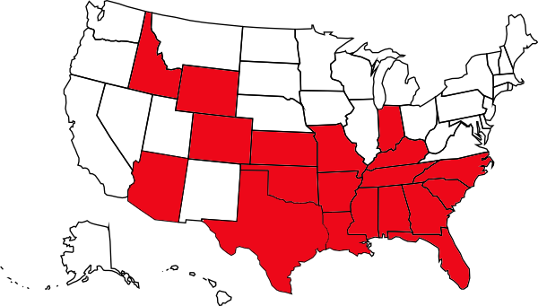
Image source: (Discipline at school (NCACPS), 2010)

Yet strangely, even though adults may use physical force to restrain or punish students, students are often arrested on school grounds for fighting with each other. When you consider the language of discipline policies, they often contain vague words such as “disrespect,” “refusal to follow directions,” and “profanity” which can mean different things to each school employee and student. In some cases, schools define “disrespect” as “tardiness, truancy, or subjective conduct such as ‘disrespect of authority’.” (Browne-Dianis, 2011) In the city of Meridian, MS these are reasons to suspend students (Advancement Project, 2013).

So what is the role of schools? Of education? According to P. Noguera, schools in the Capitalist American tradition function for three reasons (Raible & Irizarry, 2010):
- To decide who will lead and manage corporations and government, and who will be led and managed by those in charge.
- To socialize children into the “values and norms that are regarded as central to civil society and the social order.”
- To “operate as institutions of social control… as surrogate parents.”

CONTRIBUTING FACTORS TO IMPLEMENTATION OF ZERO TOLERANCE POLICIES

SCHOOL SHOOTINGS  The Gun Free School Zone Act of 1994 required that any student determined to have brought a weapon to school be expelled for a period of no less than a year. Exceptions are made to keep this act consistent with student's rights stated in the IDEA. A chief administering officer can also make case-by-case exceptions. Five years after this law was passed, the Columbine High School shooting happened. Each time a school shooting occurs in our country more pressure is put on schools to increase their zero tolerance policy.  "The era of deadly shootings likely resulted in a rebirth and solidifying of zero-tolerance weapons policy" (Mongan and Walker, 2012).  "School personnel are in a unique position of being tasked with keeping students' safe, as well as educating and advocating for their well-being. These tasks are arguably never in greater conflict than when a student is caught in possession of a weapon while on school grounds. The inital response of school workers caught in that predicament would be to remove the student in order to ensure safety for remaining students and staff. However, imagine that the student had been a 5-year-old and the weapon had been a red plastic squirt gun" (Mongan and Walker, 2012).  Social control theory: the belief that we are all animals and thus naturally capable of committing criminal acts (Mongan and Walker, 2012). | STANDARDIZED TESTING  “Here the failure of public policy to raise achievement is assigned to be the fault of the teachers and children" (Swain & Noblit, 2011, p. 468).  “Through the application of selective discipline, schools are able to target low achieving students who are at risk of not passing the test" (Swain & Noblit, 2011, p. 468).  "During the testing window, schools were more likely to distribute longer suspensions or increased rates of expulsion to keep low-performing students at home" (Swain & Noblit, 2011, p. 468).  “Schools were more likely to engage in other punitive measures during testing and in response to test-based accountability, including increasing placements in special education for marginal students, and retaining students in grades preceding high-stakes tests" (Swain & Noblit, 2011, p. 468).  "There is a long record of research demonstrating the consistent association of high-stakes exit exams with decreasing graduation rates and increased dropout rates" (Advancement Project, 2010).

LONG-TERM EFFECTS ON STUDENT WELL-BEING
Psychological Trauma
In Amite County School District show “…81% of students referred to juvenile justice and/or law enforcement in the 2008-2009, 2009-2010, and 2010-2011 school years were of students in the 8th grade or younger, and included several students in the 2nd and 3rd grades" (Advancement Project, 2013, p.9). Children this young being referred into an adult prison system causes unnecessary psychological harm. “..Unjust disciplinary consequences are frequently traumatizing for young people, leading to public humiliation, diminished self-worth, and distrust of school officials. They also often trigger a cycle of disengagement from schools, where students become less trusting and more resentful of their teachers, losing the “connectedness” that is such a critical component of academic success. As youth become more alienated, they also become more likely to engage in risky behaviors, violence, and alcohol and substance abuse (Advancement Project, 2012).” "When punishment is not appropriate for the crime, students can lose trust in the way society handles critical issues, so that their trust and respect for authority are compromised" (Kajs, 2006, p.22).

In some cases, the suspension and subsequent legal consequences of their actions has led students to commit suicide (Browne-Dianis, 2011). In fact, the Advancement Project states that “incarcerated youth are more likely to attempt suicide than their non-incarcerated peers, and the completed suicide rate is four times the completed suicide rate of youth overall" (Advancement Project, 2013, p. 10).

Noam, Warner, and Van Dyken (2001) indicate the following as potential long-term effects of zero tolerance policies on youth:
- youth end up viewing themselves as "bad," incompetent, deviant
- youth learn that you either succeed or fail, without opportunities to correct mistakes
- the likelihood of youth engaging in further self-destructive acts increases
- youth develop an understanding that they are helpless and that they do not have control over their own lives
- youth lose trust in adults

Legal Ramifications
Archer makes the point that “schoolchildren who are removed from mainstream education environments, even for short periods of time, are far more likely to become involved with the criminal justice system, use drugs, or drop out of school" (Archer, 2009/2010, p. 868-869). This is an important statistic to consider especially when combined with the knowledge that almost half of the adult prison population is comprised of high school dropouts" (cited in Swain & Noblit, 2011).

Education Implications
“…schools rarely offer adequate transition or reentry counseling programs for students who are returning form residential settings, thus increasing the likelihood of further failure for these students" (Wald & Losen, 2003, p. 99). In addition, students are usually behind academically due to missed months or years of school. Some schools guide students towards alternative schools that do not meet academic goals (Wald & Losen, 2003). To make matters even more long-term, Incidents may be reflected on student records when applying for colleges, jobs or to enter the military (Browne-Dianis, 2011).
CONNECTIONS TO MAJOR CONCEPTS
Below you can see a chart that illustrates the National Middle School Suspension rates from 2006 and shows the disparities in both race and gender.

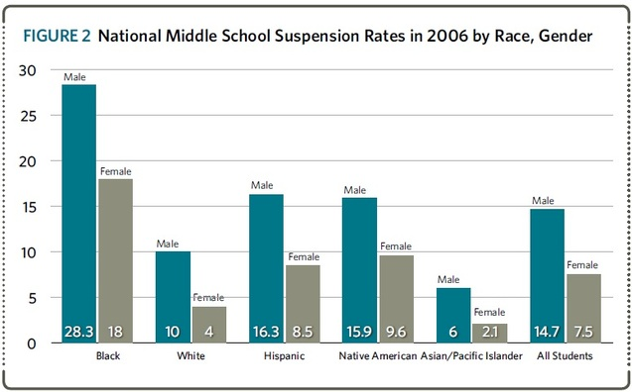
*Chart is taken from Losen & Skiba, 2010

RACISM | During the 2005 to 2006 school year…white students consisted of approximately 67% of the student population but only accounted for 53% of all corporal punishments. In the same year, black students constituted seventeen percent of the student population and were corporally punished at over two times the rate of white students (Smith, 2009).  During the 2000 to 2001 school year, black students were 17% of the student population but 34% of suspensions and 31% of expulsions. Whites were 62% of the student population, and only accounted for 48% of suspensions and 49% of expulsions (Smith, 2009).  Once prosecuted, “black youth are nine times more likely than white youth to receive an adult prison sentence” (Smith, 2009,p.1012).  Since the 1970s, “K-12 suspension rates have at least doubled… for all non-Whites. You can see a chart on the History Page). (Suspended Education, Losen & Skiba)  What message is being sent to young people when, as Giroux (2003) cites in his article: “in a state such as New York, “more Blacks entered prison just for drug offenses than graduate from the state’s massive university system with undergraduate, masters, and doctoral degrees combined in the 1990s" (Street, 2001,p.26).  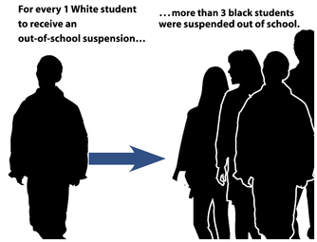  Image Source: Advancement Project, 2013

CLASSISM | There is an undeniable class system in place in our society and “…views of violence are shaped by class experiences and the neighborhood in which one lives. To many, violence is viewed as a consequence of poverty. Duncan and Brooks-Gunn (2000) found that poor children are 2.2 times more likely to experience a violent crime. This implies that poor neighborhoods are exposed to more violent episodes, which in turn, affect the school culture in those areas."  There are structural elements in place in our schools that serve to prevent upward class mobility. Giroux states: “what are we to make of a social order… whose priorities suggest to urban youth that U.S. society is willing to invest more in sending them to jail than in providing them with high-quality schools and a decent education? How does a society justify housing poor students in schools that are unsafe, decaying, and with few or no extracurricular activities, while at the same time it spends five times more annually—as high as $20,000 in many suburban schools—on each middle-class student... (Giroux, 2003)  This gap in financial support leads to a higher likelihood of “overcrowded classes; weak curricula; insufficiently trained teachers and high teacher turnover; low standardized test scores; high grade retention and [push]out rates; and low rates of parental involvement" (Smith, 2009).
ABLEISM | Students with Disabilities are protected under Individuals with Disabilities Act that states that these students have a right to a Free and Appropriate Public Education (FAEP) and must be educated in their Least Restrictive Environment (LRE). The student can only be removed from general education classes if “because of the nature or severity of the student’s disability, he or she cannot be educated there successfully" (Turnbull, Turnbull, & Wehmeyer, 2007, p.17).  However, these students with special needs can become especially vulnerable to harsh disciplinary policies due to their often challenging behavior and limited social skills. Often, school and district discipline policies do not protect these students. For example, “In Richardson, Texas, a 14-year-old boy with Asperger’s syndrome was given a $364 police citation in May 2009 for using an expletive in his classroom" (Advancement Project, 2010, p. 13).
HETEROSEXISM | LGBTQ youth are often the victims of bullying. In fact“…over 8 out of 10 LGBTQ youth report being verbally harassed about their sexual orientation at school, and 6 out of 10 report feeling unsafe in school" (Advancement Project, 2012, p. 3). Because of the increased likelihood of being in a conflict that can result in a physical altercation, there are many ways that these youth become targeted. In addition “…the use of harsh disciplinary actions typically leads to increased reporting, which has inadvertently “outed” many LGBTQ youth to their parents or peers, and can be both traumatic and dangerous for these young people" (Advancement Project, 2012, p. 10). This can lead to social and emotional ramifications that these youth are not prepared for.
References

Discipline at school (NCACPS). (2010, July 1). Retrieved from The Center for Effective Discipline: http://www.stophitting.com/index.php?page=statesbanning

Advancement Project. (2012). Two wrongs don't make a right: Why zero tolerance is not the solution to bullying. 1-17.

Advancement Project. (2013, January). Handcuffs on success. 1-25.

Archer, D. N. (2009/2010). Introduction: Challenging the school-to-prison pipeline. New York Law School Law Review, 54, 867-872.

Browne-Dianis, J. (2011). Stepping back from zero tolerance. Educational Leadership(Fall), 24-28.

Giroux, H. A. (2003). Zero tolerance, domestic militarization, and the war against youth. Social Justice, 30(2), 59-65.

Mongan, P., & Walker, R. (2012). “The Road to Hell Is Paved With Good Intentions”: A Historical, Theoretical, and Legal Analysis of Zero-Tolerance Weapons Policies in American Schools. Preventing School Failure, 56(4), 232-240.

Raible, J., & Irizarry, J. G. (2010). Redirecting the teacher's gaze: Teacher education, youth surveillance and the school-to-prison pipeline. Teaching and Teacher Education, 1196-1203.

Smith, C. D. (2009). Deconstructing the pipeline: Evaluating school-to-prison pipeline equal protection cases through a structural racism framework. Fordham Urb. L.J., XXXVI, 1009-1049.

Stephey, M. (2013, February 24). Corporal punishment in schools. Retrieved from Time U.S.: http://www.time.com/time/nation/article/0,8599,1915820,00.html

Swain, A. E., & Noblit, G. W. (2011). Education in a punitive society: An introduction. Urban Rev, 465-475.

Turnbull, A., Turnbull, R., & Wehmeyer, M. L. (2007). Exceptional lives: Special education in today's schools (5 ed.). Upper Saddle River, New Jersey: Pearson Education, Inc.

Wald, J., & Losen, D. L. (2003). Defining and redirecting a school-to-prison pipeline. New Directions for Youth Development(99), 9-15.

Wright, J. (1998). Treating children as equals. New Renaissance Magazine, 13-14.

From the website Adultism and the Criminalization of Students in Schools (http://957414677668313364.weebly.com). This page accessed 13 Nov 2016 at http://957414677668313364.weebly.com/current-status.html.

