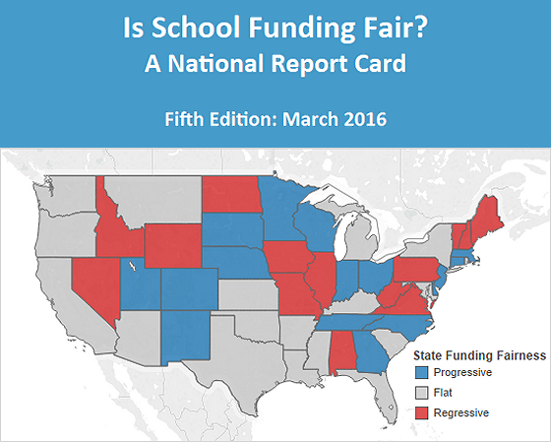
UNFAIR SCHOOL FUNDING SHORTCHANGES STUDENTS ACROSS THE NATION
Newark, NJ, March 16, 2016 – Is School Funding Fair? A National Report Card (NRC), released by the Education Law Center (ELC) today, finds that in most states public school funding remains unfair and inequitable, depriving millions of U.S. students of the opportunity for school success.

The fifth edition of the NRC uses funding data from the 2013 Census fiscal survey, the most recent data available. The report goes beyond raw per-pupil calculations to evaluate whether states are fairly funding their public schools by distributing funding relative to student poverty. To capture the differences in state public education finance, the NRC uses four interrelated "fairness measures" – Funding Level, Funding Distribution, Effort, and Coverage – that allow for state comparisons while controlling for regional differences.

The NRC released today shows little improvement over the past five years in those states that consistently fail to direct additional funding to districts with high levels of need, as measured by student poverty. The report also finds striking differences in levels of funding for K-12 education across the states, even when adjusted for regional variations in cost. Alaska and New York, the states with the highest funding levels, spend more than two and half times what is spent by Utah and Idaho, the states with the lowest funding levels.

The NRC's other key findings include:
- Funding levels show wide disparities among states, ranging from a high of $17,331 per pupil in Alaska, to a low of $5,746 in Idaho.
- Many of the states with the lowest funding levels, such as California, Idaho, Nevada, North Carolina, and Texas, invest a very low percentage of state economic capacity in funding public education.
- Fourteen states, including Pennsylvania, North Dakota, and Illinois, are regressive, providing less funding to school districts with higher concentrations of low-income students.
- Certain regions of the country exhibit a double disadvantage – many states with low funding overall add no additional funds for concentrated student poverty. These include Alabama, Mississippi, and Florida in the Southeast, and Colorado, Arizona, and New Mexico in the Southwest.
- Only a handful of states – Delaware, Massachusetts, Minnesota, New Jersey, and Ohio – have generally high funding levels while also providing significantly more funding to districts where student poverty is highest.
- Low rankings on school funding fairness correlate to poor state performance on key indicators of essential education resources, including less access to early childhood education, non-competitive wages for teachers, and higher teacher-to-pupil ratios.

